SIMATS ENGINEERING
CO5-ASSESSMENT TOOL 3 (AT3): HDL CODE ERROR DEBUGGING
COURSE: DIGITAL CIRCUITS | COURSE CODE: ECA0202

Student Name: Naveen Kumar N | Register No: 192512297
Topic: 4:1 Multiplexer Verilog Debugging

Item | Outcome
1. Given Code | module mux4to1(  input [3:0] I,  input [1:0] S,  output reg Y  );  always @(*)  case(S)  2'b00: Y = I[0];  2'b01: Y = I[1];  2'b10: Y = I[2];  2'b11: Y = I[3];  endmodule
2. Expected Code Output | The module is intended to describe a 4-to-1 Multiplexer where output Y reflects one of the 4 inputs (I[0], I[1], I[2], I[3]) depending on the 2-bit select line S (2'b00 selects I[0], 2'b01 selects I[1], 2'b10 selects I[2], 2'b11 selects I[3]).
3. Observed Fault / Symptom | • Compilation / Syntax Error: Parser reports unexpected 'endmodule', expecting an 'endcase' to close the case statement block.  • Simulation / Synthesis fails due to unclosed procedural construct.
4. Error Identified | 1. Missing 'endcase' keyword: The 'case(S)' block opened inside the combinational 'always @(*)' procedural block was never terminated with 'endcase'.  2. Missing 'default' branch (Best Practice): Although 2-bit covers all 4 binary states, standard RTL coding guidelines recommend including a 'default' statement to avoid unintended latch inference in synthesis when inputs have 'x' or 'z' states.
5. Correction Made | 1. Added the required closing statement 'endcase' before 'endmodule'.  2. Added a 'default: Y = 1'b0;' assignment to ensure robust, synthesizable combinational logic behavior.
6. Corrected HDL Code | module mux4to1(  input [3:0] I,  input [1:0] S,  output reg Y  );  always @(*) begin  case(S)  2'b00: Y = I[0];  2'b01: Y = I[1];  2'b10: Y = I[2];  2'b11: Y = I[3];  default: Y = 1'b0;  endcase  end  endmodule
7. Verification / Simulation Output | 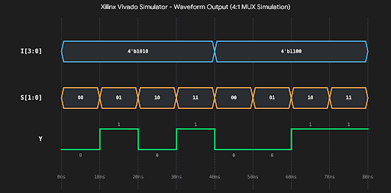
8. Final Result & Technical Justification | • Result: The syntax error was resolved by properly terminating the procedural case construct with 'endcase'.  • Technical Justification: In Verilog HDL, every 'case', 'casex', or 'casez' statement must be explicitly closed with an 'endcase' token prior to module closure. Omitting it leads to syntax parsing failure. Adding 'begin...end' and 'default' ensures clean synthesis into a pure multiplexer combinational logic without latch generation.

